No. | INSTRUCTIONS |  | KEY POINTS / CONTACTS
1. | Check all electrical components are in working order. | 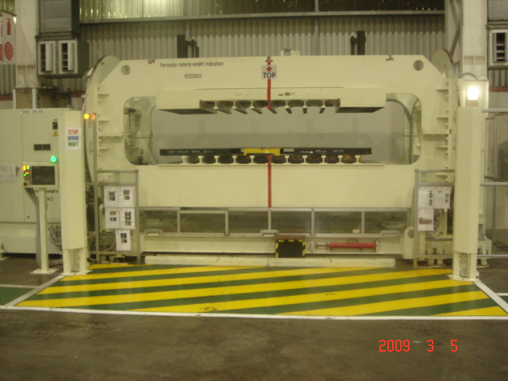 | ENSURE PERSONNAL PROTECTIVE EQUIPMENT (PPE) IS WORN: -  1. HARD HAT  2. STEEL CAP BOOTS  3. GLOVES  ENSURE LOCK- OUTS AND SAFETY BLOCKS ARE USED AT ALL TIMES.
2. | Open all electrical panels and check for discolored or burnt fuses, wires etc. | 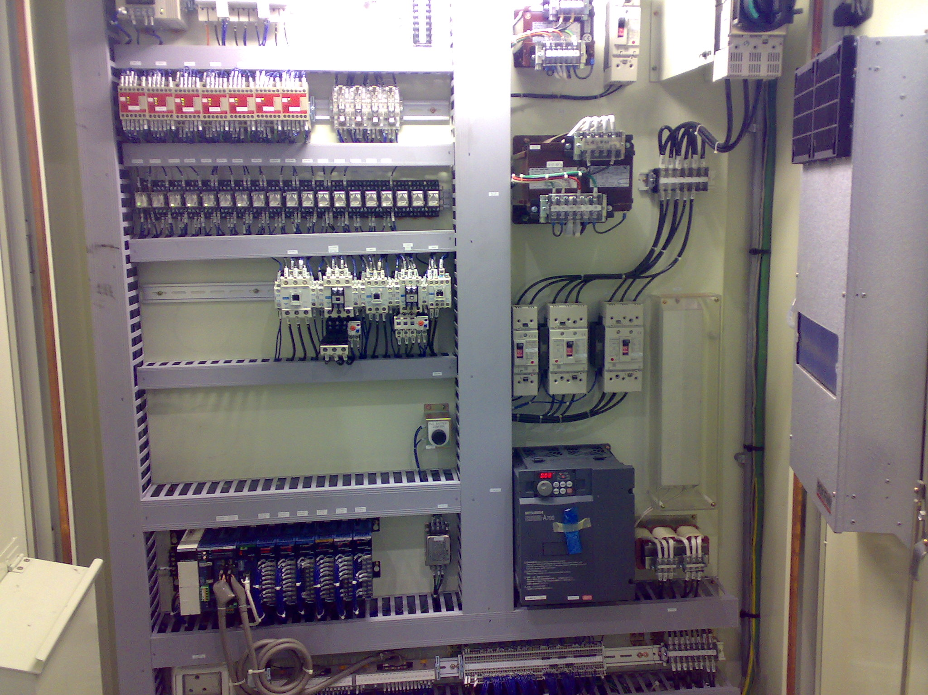
3. | Check all safety door switches are in working order. | 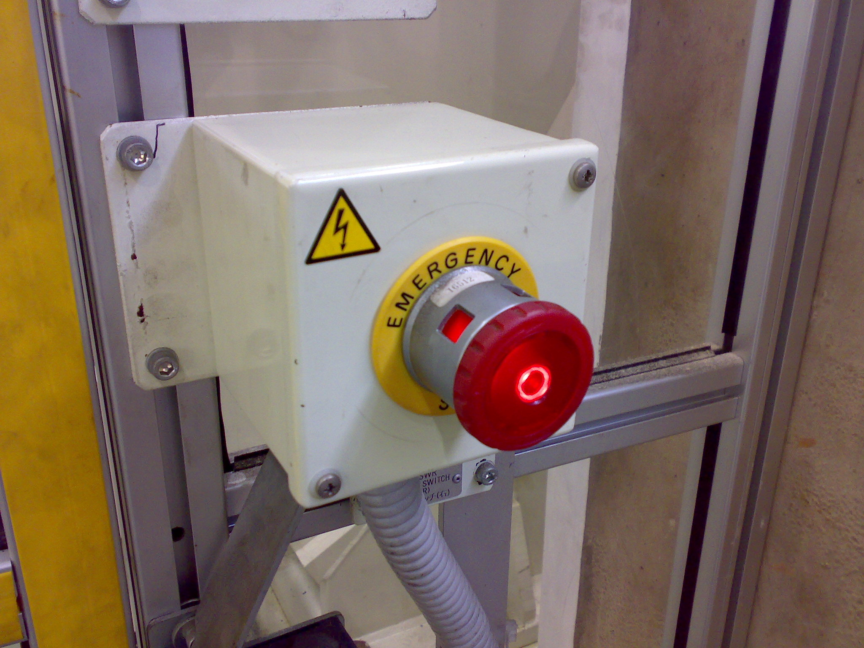
4. | Check all motors. | 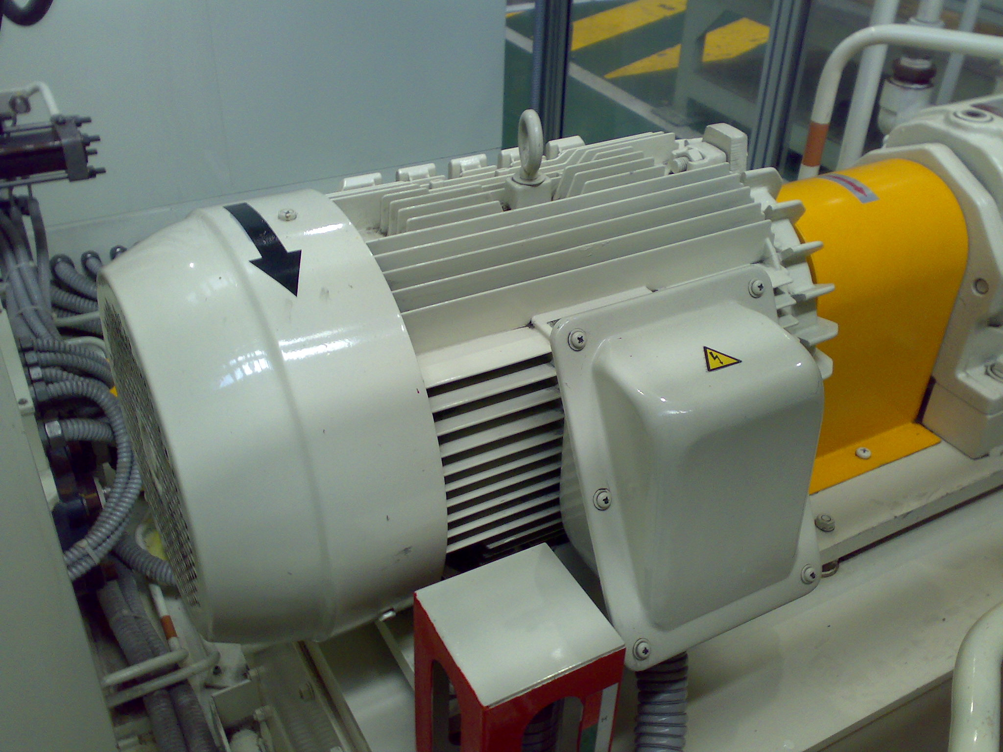
5. | Check the operation of all sensors and limit switches. Check for any loose connections. | 